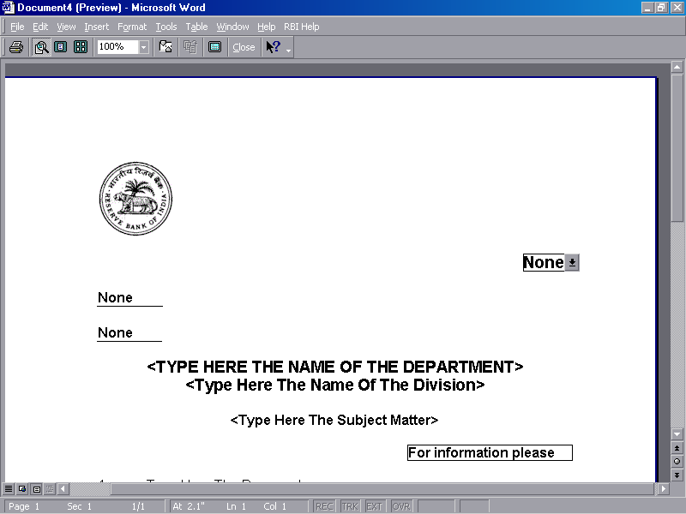
Reserve Bank of India
Department of Statistics and Information Management
Consumer Confidence Survey, March 2022
Block I: Respondent’s Details
Name
Address | Address1 - House Number
Address | Address2 - Colony/Street
Address | Landmark
Address | City |  |  |  |  | Pin Code
Telephone Number
Age of the respondent | ___________ (in completed years, 21 years and above)
Gender | Male |  |  |  | Female
Occupation | Salaried Employee  [1] |  |  | Self Employed/ Business [2] |  | Homemaker [3] | Daily worker  [4] |  |  | Retired Person  [5] |  |  | Others (Incl. Unemployed, students, etc.)  [6]
Average Monthly Income | Less than ₹ 5 thousand [1] |  |  |  |  | ₹ 5 thousand - ₹ 10 thousand [2] |  |  |  | ₹ 10 thousand - ₹ 25 thousand [3]
Average Monthly Income | ₹ 25 thousand - ₹ 50 thousand [4] |  |  |  |  | ₹ 50 thousand - ₹ 1 lakh [5] |  |  |  | ₹ 1 lakh and above [6]
Family Members | 1 or 2 [1] |  |  |  |  | 3 or 4 [2] |  |  | 5 and more [3]
Number of Earning members
Educational Qualification |  | Illiterate [1] |  |  |  | Below 5th Std [2] |  |  | 5th Std-Below 10th Std [3]
 |  | 10th Std-Below 12th Std [4] |  |  |  | 12th Std [5] |  |  | Graduate [6] |  |  |  |  | Post Graduate [7]
Block II: Respondent’s Perceptions and Expectations
Q. No. |  | As compared with one -year ago |  |  | One-year from now
Q. No. |  | Improved/ Increased | Remained the same | Worsened/ Decreased | Will Improve/ Increase | Remain the same | Will Worsen/ Decrease
1. | General economic situation in the country | [1] | [2] | [3] | [1] | [2] | [3]
2. | Income | [1] | [2] | [3] | [1] | [2] | [3]
3. | Overall Spending* | [1] | [2] | [3] | [1] | [2] | [3]
3(a) | Expenditure on essential items$ | [1] | [2] | [3] | [1] | [2] | [3]
3(b) | Expenditure on non-essential items$ | [1] | [2] | [3] | [1] | [2] | [3]
4. | Employement scenario | [1] | [2] | [3] | [1] | [2] | [3]
5(a) | Overall prices of goods and services | [1] | [2] | [3] | [1] | [2] | [3]
5(b) | Rate of price changes# | [1] | [2] | [3] | [1] | [2] | [3]
* If you choose (1) in Question 3, please answer Question 6_1. If you choose (3) in Question 3, please answer Question 6_2.
$ Essential items comprise of food, housing, fuel & electricity, essential clothing, education, medical amenities, transportation etc. Non-essential items comprise of consumer durables, motor vehicles, gold & jewelry, expenses on hotel & restaurant etc.
# If you choose (1) in Question 5(a), please answer Question 5(b).

Q.No.6_1 Why have you increased your (or other family members’) spending? (Choose all applicable answers)
Yes No
a. | Because your income has increased. | [1] | [2]
b. | Because value of your investments/wealth has increased. | [1] | [2]
c. | Because your expenditure towards large ticket purchases such as real estate, car, consumer durable goods has increased. | [1] | [2]
d. | Because the cost of consumer goods, cost of services (e.g., medical, education, transport, etc.) has gone up. | [1] | [2]
e. | Others (Please Specify) | [1] | [2]

Q.No.6_2 Why have you decreased your (or other family members’) spending? (Choose all applicable answers)
Yes No
a. | Because your income has decreased. | [1] | [2]
b. | Because value of your investments/wealth has decreased. | [1] | [2]
c. | Because your expenditure towards large ticket purchases such as real estate, car, consumer durable goods has decreased. | [1] | [2]
d. | Because the cost of consumer goods, cost of services (e.g., medical, education, transport, etc.) has gone down. | [1] | [2]
e. | Others (Please Specify) | [1] | [2]

Q.No.7 How you describe the current financial situation of your household –
Saving a lot | Saving a little | Just making ends meet | Drawing on past saving | Running debt
*****

